Department of Computer Engineering TE Computer-A (2020-21 Sem I) Computer Networks Practical Assignment B2 [Max Marks: 10]
By : Himanshu Shekhar Padhi (3325)

( B2_a )

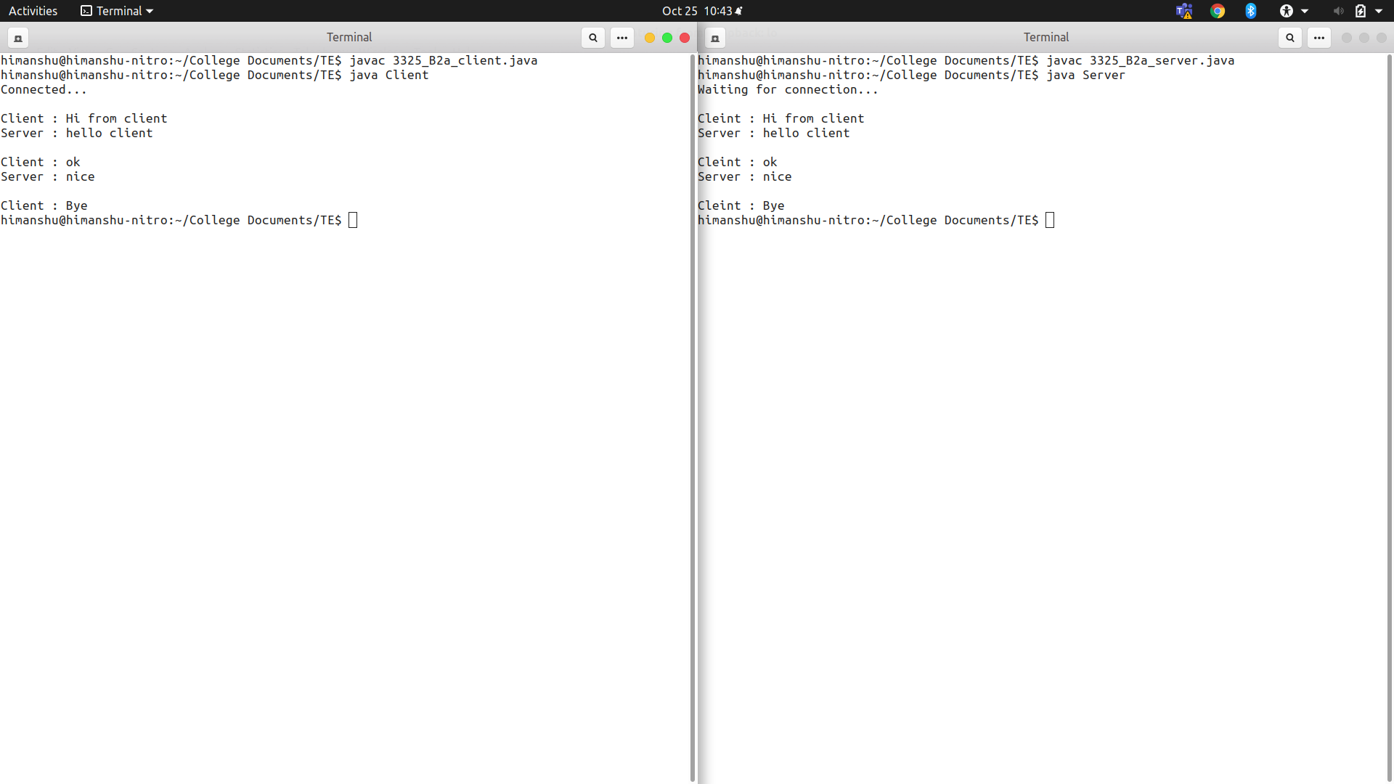
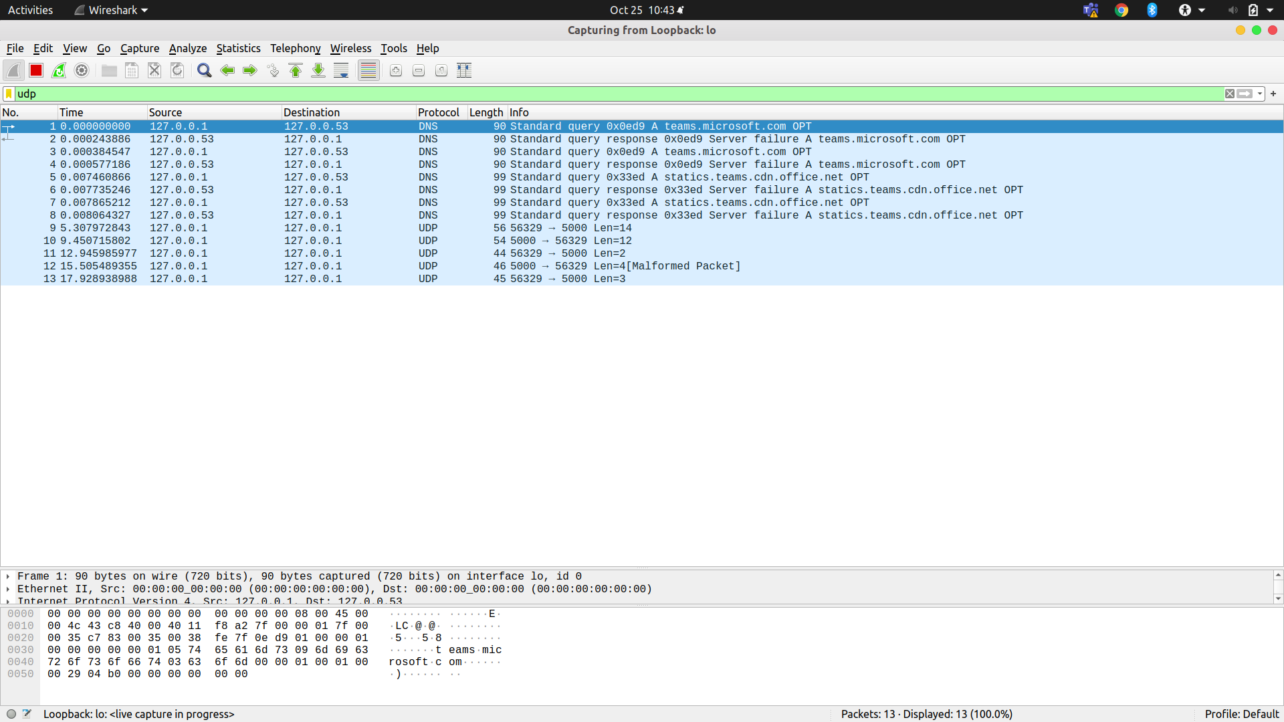

( B2_b )

